**MYSQL Assignment**

1. **Write a query to find the total number of students.**

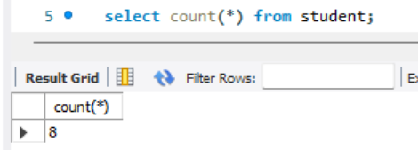

1. **Write a query to find which department john belongs to.**

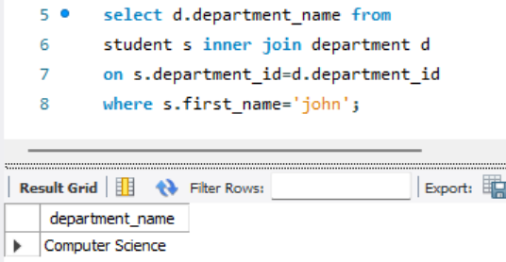

1. **List All Departments with Their Number of Students (Including Departments with No Students)**

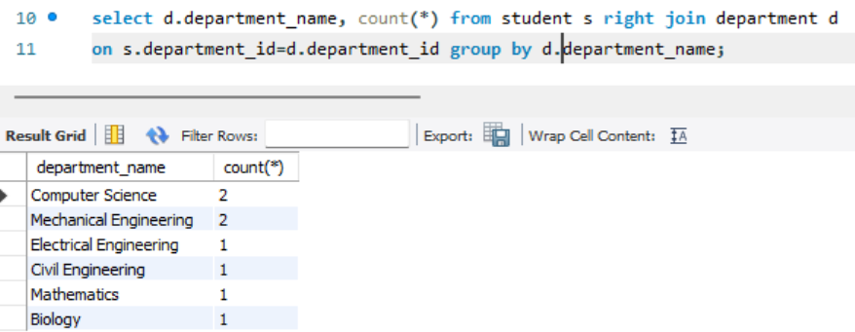

1. **Select all students with their department and address.**

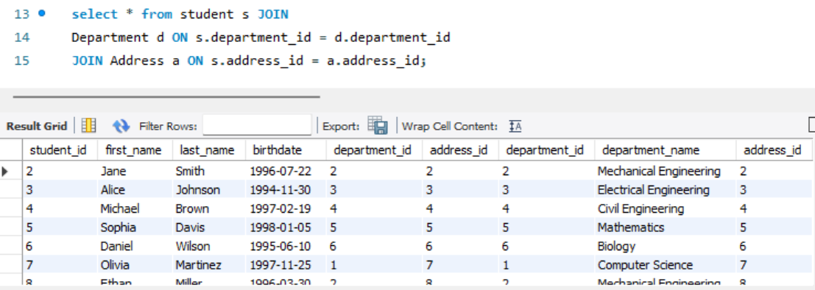

1. **Find all students who are in the 'Computer Science' department**

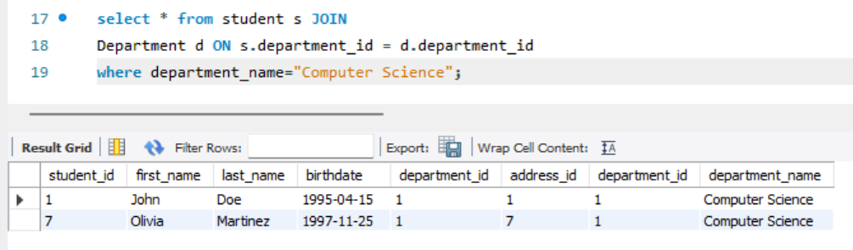

1. **Update Jane’s city name to New York.**



1. **Delete a student from the student table.**



1. **Select all students with their department and address in New York.**

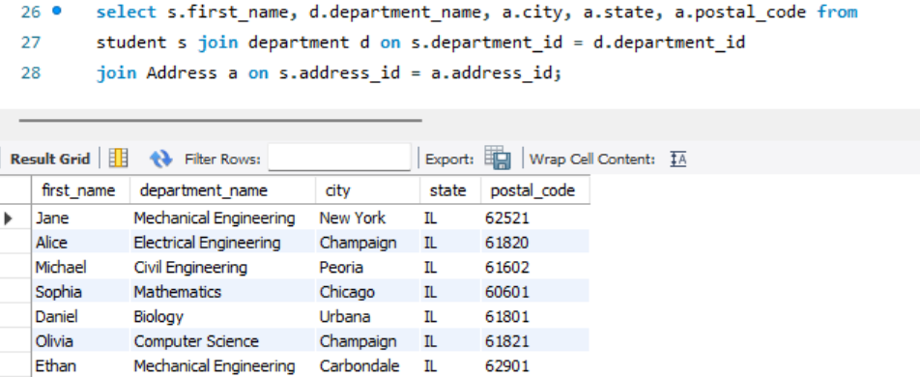

1. **Count how many students are in each department**

**\**

1. **Find students who live in 'Springfield'**

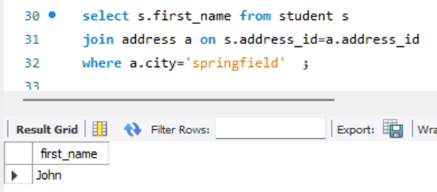

1. **Select students whose birthday falls in February**

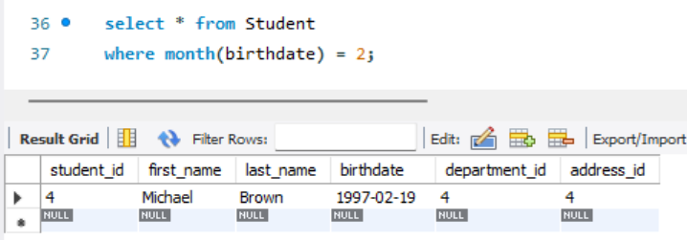

1. **Get the department and address details for a specific student, example john**

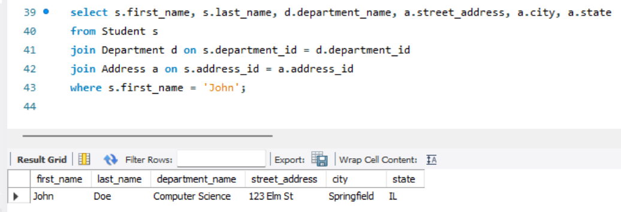

1. **Find all students who are born within 1995 to 1998**

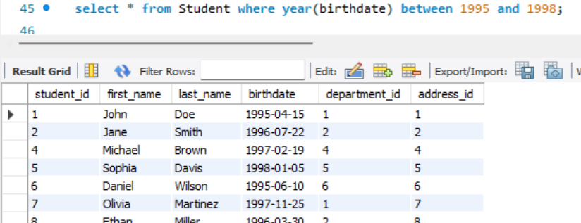

1. **List all students and their corresponding department names, sorted by department**

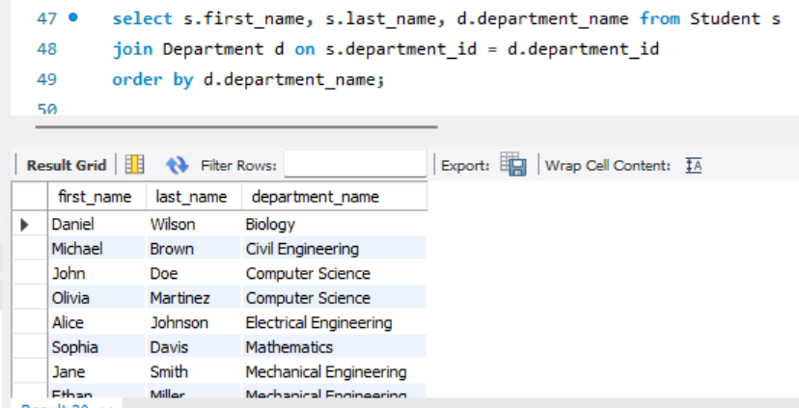

1. **Find the number of students in each department who are living in 'Champaign'**

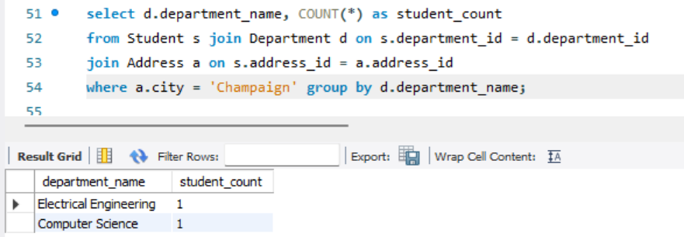

1. **Retrieve the names of students who live on 'Pine' street**

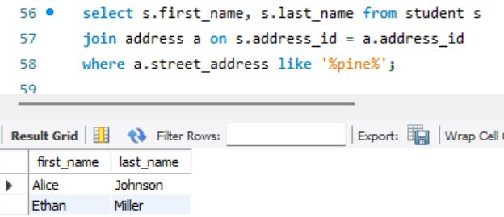

1. **Update the department of a student with student_id = 6 to 'Mechanical Engineering'**

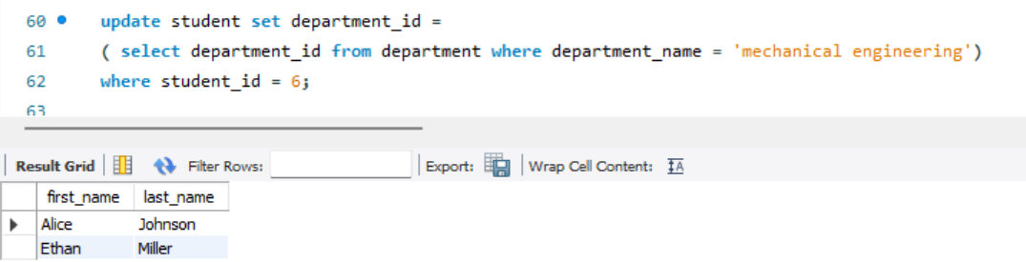

1. **Find the student(s) who live in the city 'Chicago' and are in the 'Mathematics' department**

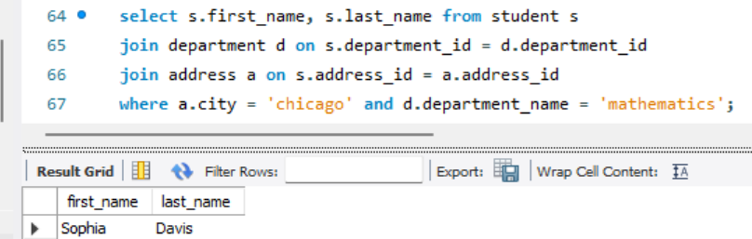

1. **List all students who have an address in 'Urbana' or 'Peoria'**

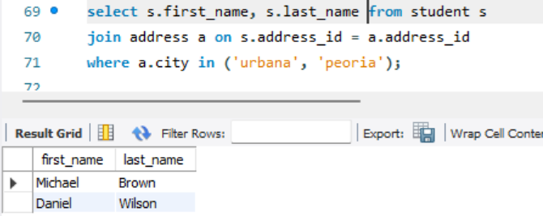

1. **Find the student with the highest student_id**

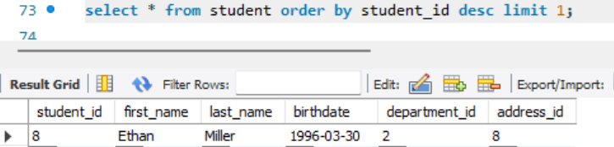

1. **Find all students who are not in the 'Computer Science' department**

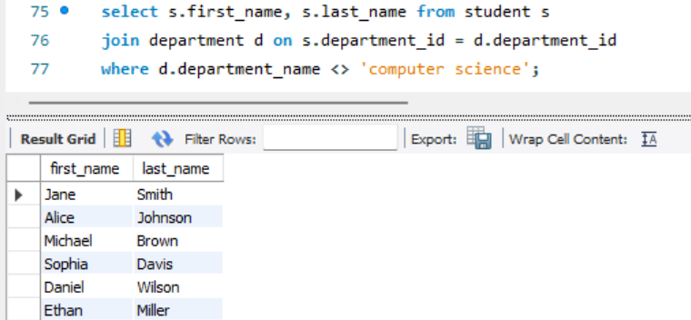

1. **Count the total number of addresses in the 'Champaign' city**

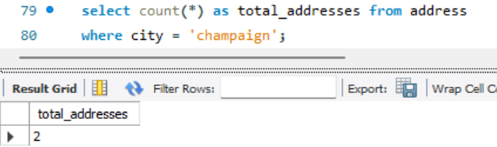

1. **Find the name of the student who lives at '520 Pine Rd'**

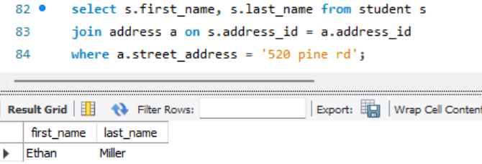

1. **Get the average age of students in the 'Electrical Engineering' department**

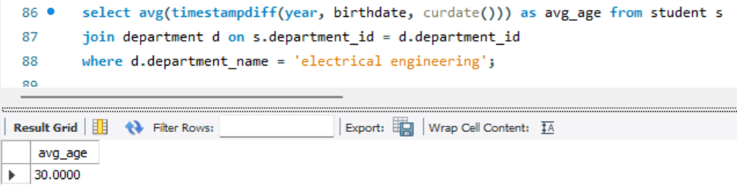

1. **List the students, their department, and the city where they live, but only for those in departments starting with 'M'**

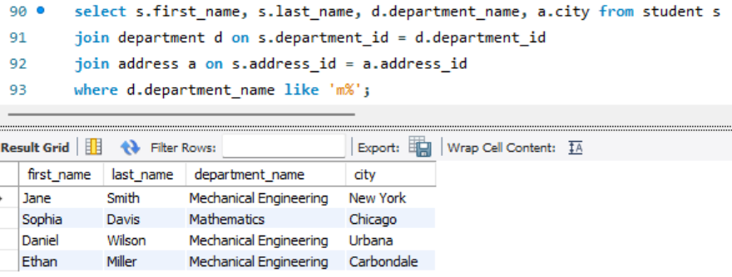

1. **Delete a student from the 'Mechanical Engineering' department**



**Order.sql:**

1. **Retrieve All Orders with Their Customer Details and Current Status**

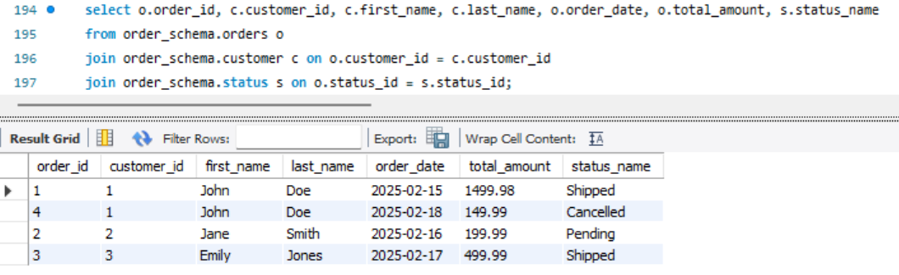

1. **Get the Total Value of Orders for a Given Customer in a Specific Time Period**

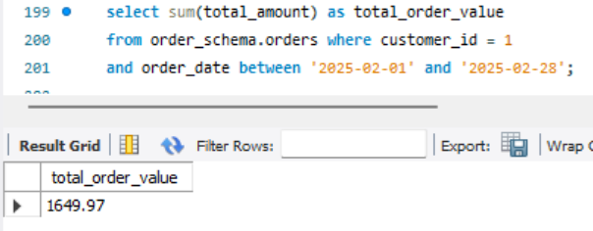

1. **Find the Most Expensive Order by Customer**

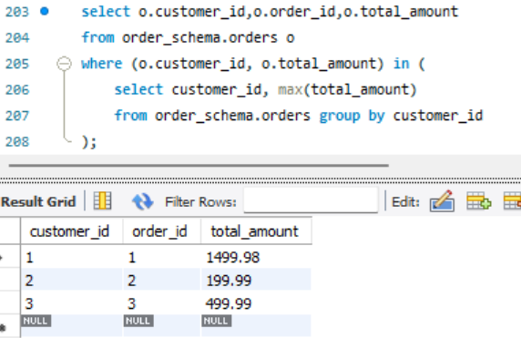

1. **Find the Total Revenue for Each Product Based on Orders**

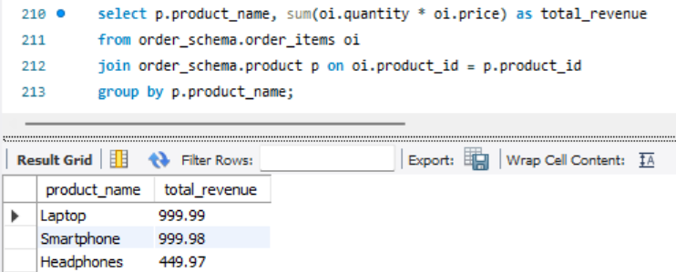

1. **Write a query to retrieve the order ID, customer ID, and the total amount of each order. If the total amount is null, display '0.00' instead.**

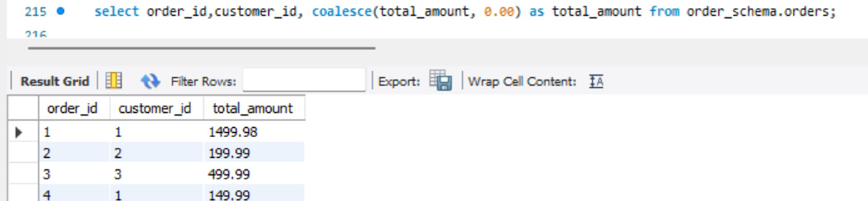

1. **Retrieve the Order History of a Specific Customer Along with Product Details**

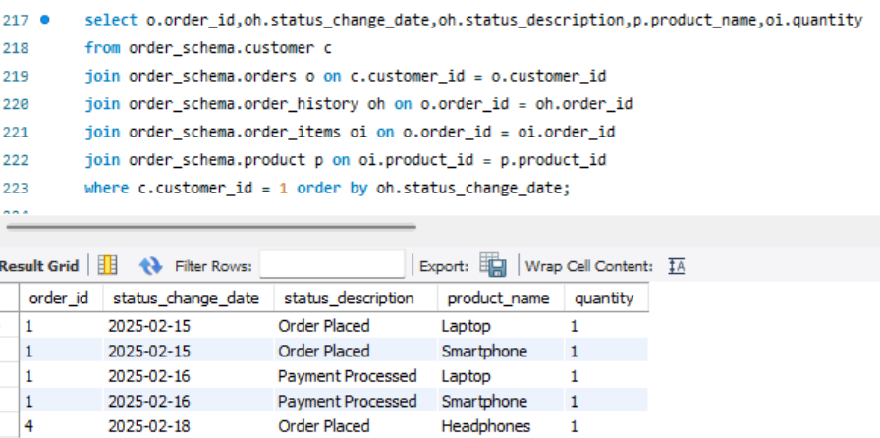

1. **Get the Average Order Value Per Customer in the Last 30 Days.**

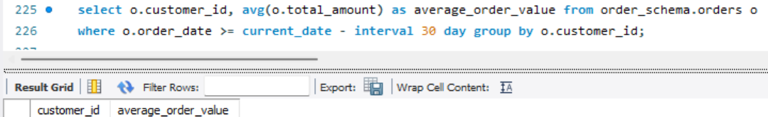

1. **Get the Top 5 Products with the Highest Number of Orders.**

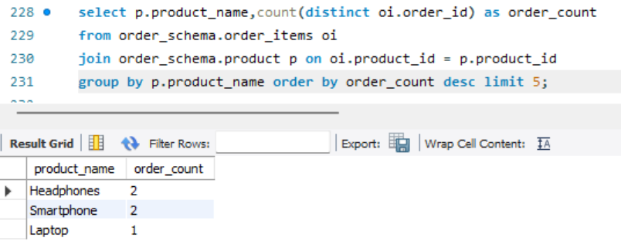

1. **Get the Customers Who Have Not Placed Any Orders in the Last 60 Days**

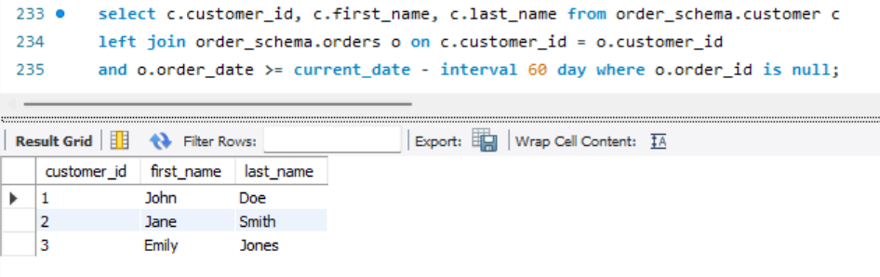

1. **List the Orders with Products Ordered More Than Once, Sorted by Order Date**

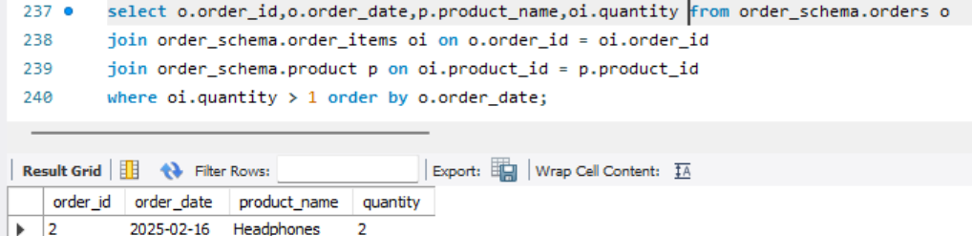

1. **Retrieve the Number of Orders and Total Revenue for Each Status**

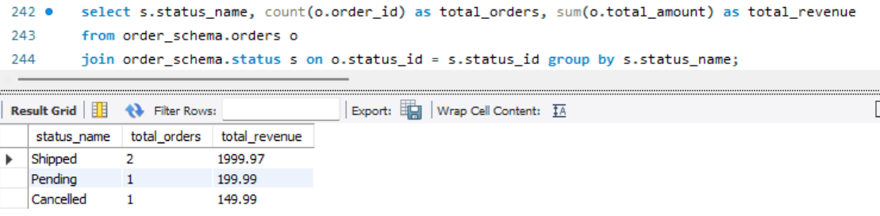

1. **Find Customers Who Have Ordered More Than a Specific Product (e.g., "Laptop")**

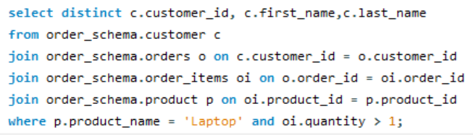

1. **Find the Products That Have Never Been Ordered**

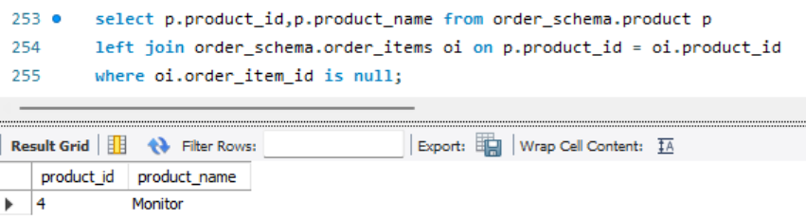

1. **Get the Total Quantity of Products Ordered in the Last 7 Days**

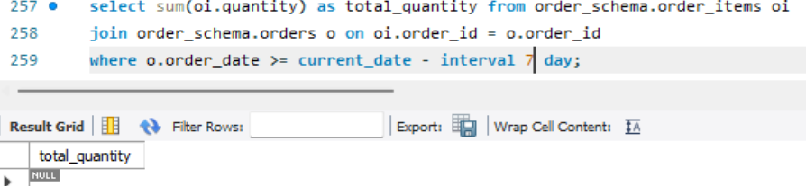

1. **Create a view named product_details that includes all columns from the product table.**



1. **Create a view named order_summary that includes the order_id, customer_id, order_date, total_amount, and status_name (from the status table) for each order.**

